Mock It Till You Rock It Social Media Sample Text
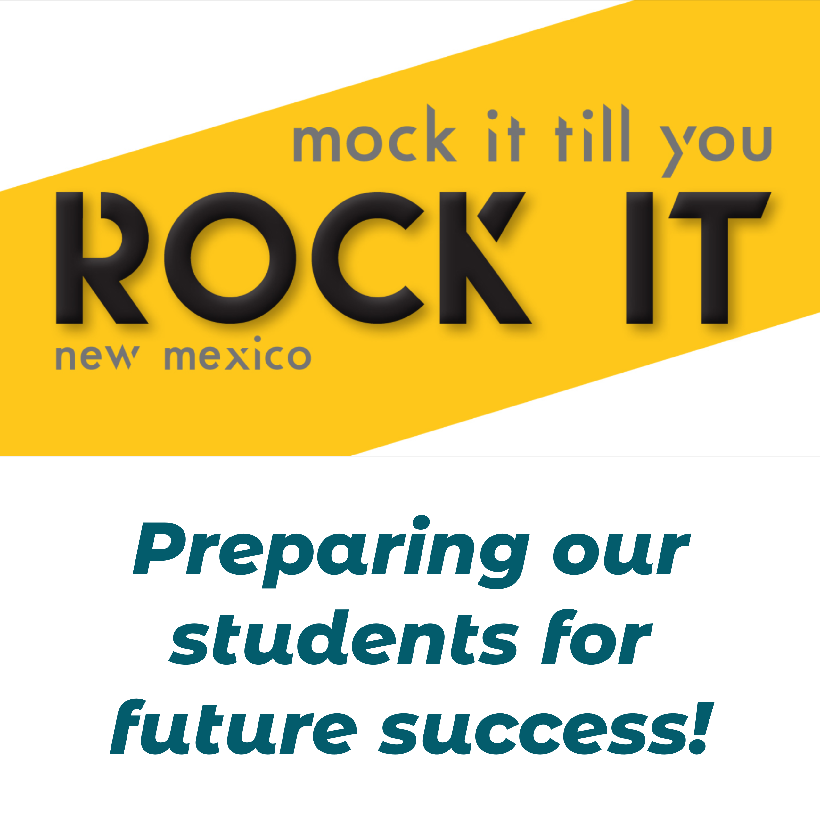
Post 1:
Mock Interview Event {insert date}
Mock interviews help students feel ready when it comes to the real thing. Businesses, join us as interviewers for our event! @NMDWS #MockItTillYouRockItNM #mockinterviews #students #softskills #careerreadiness

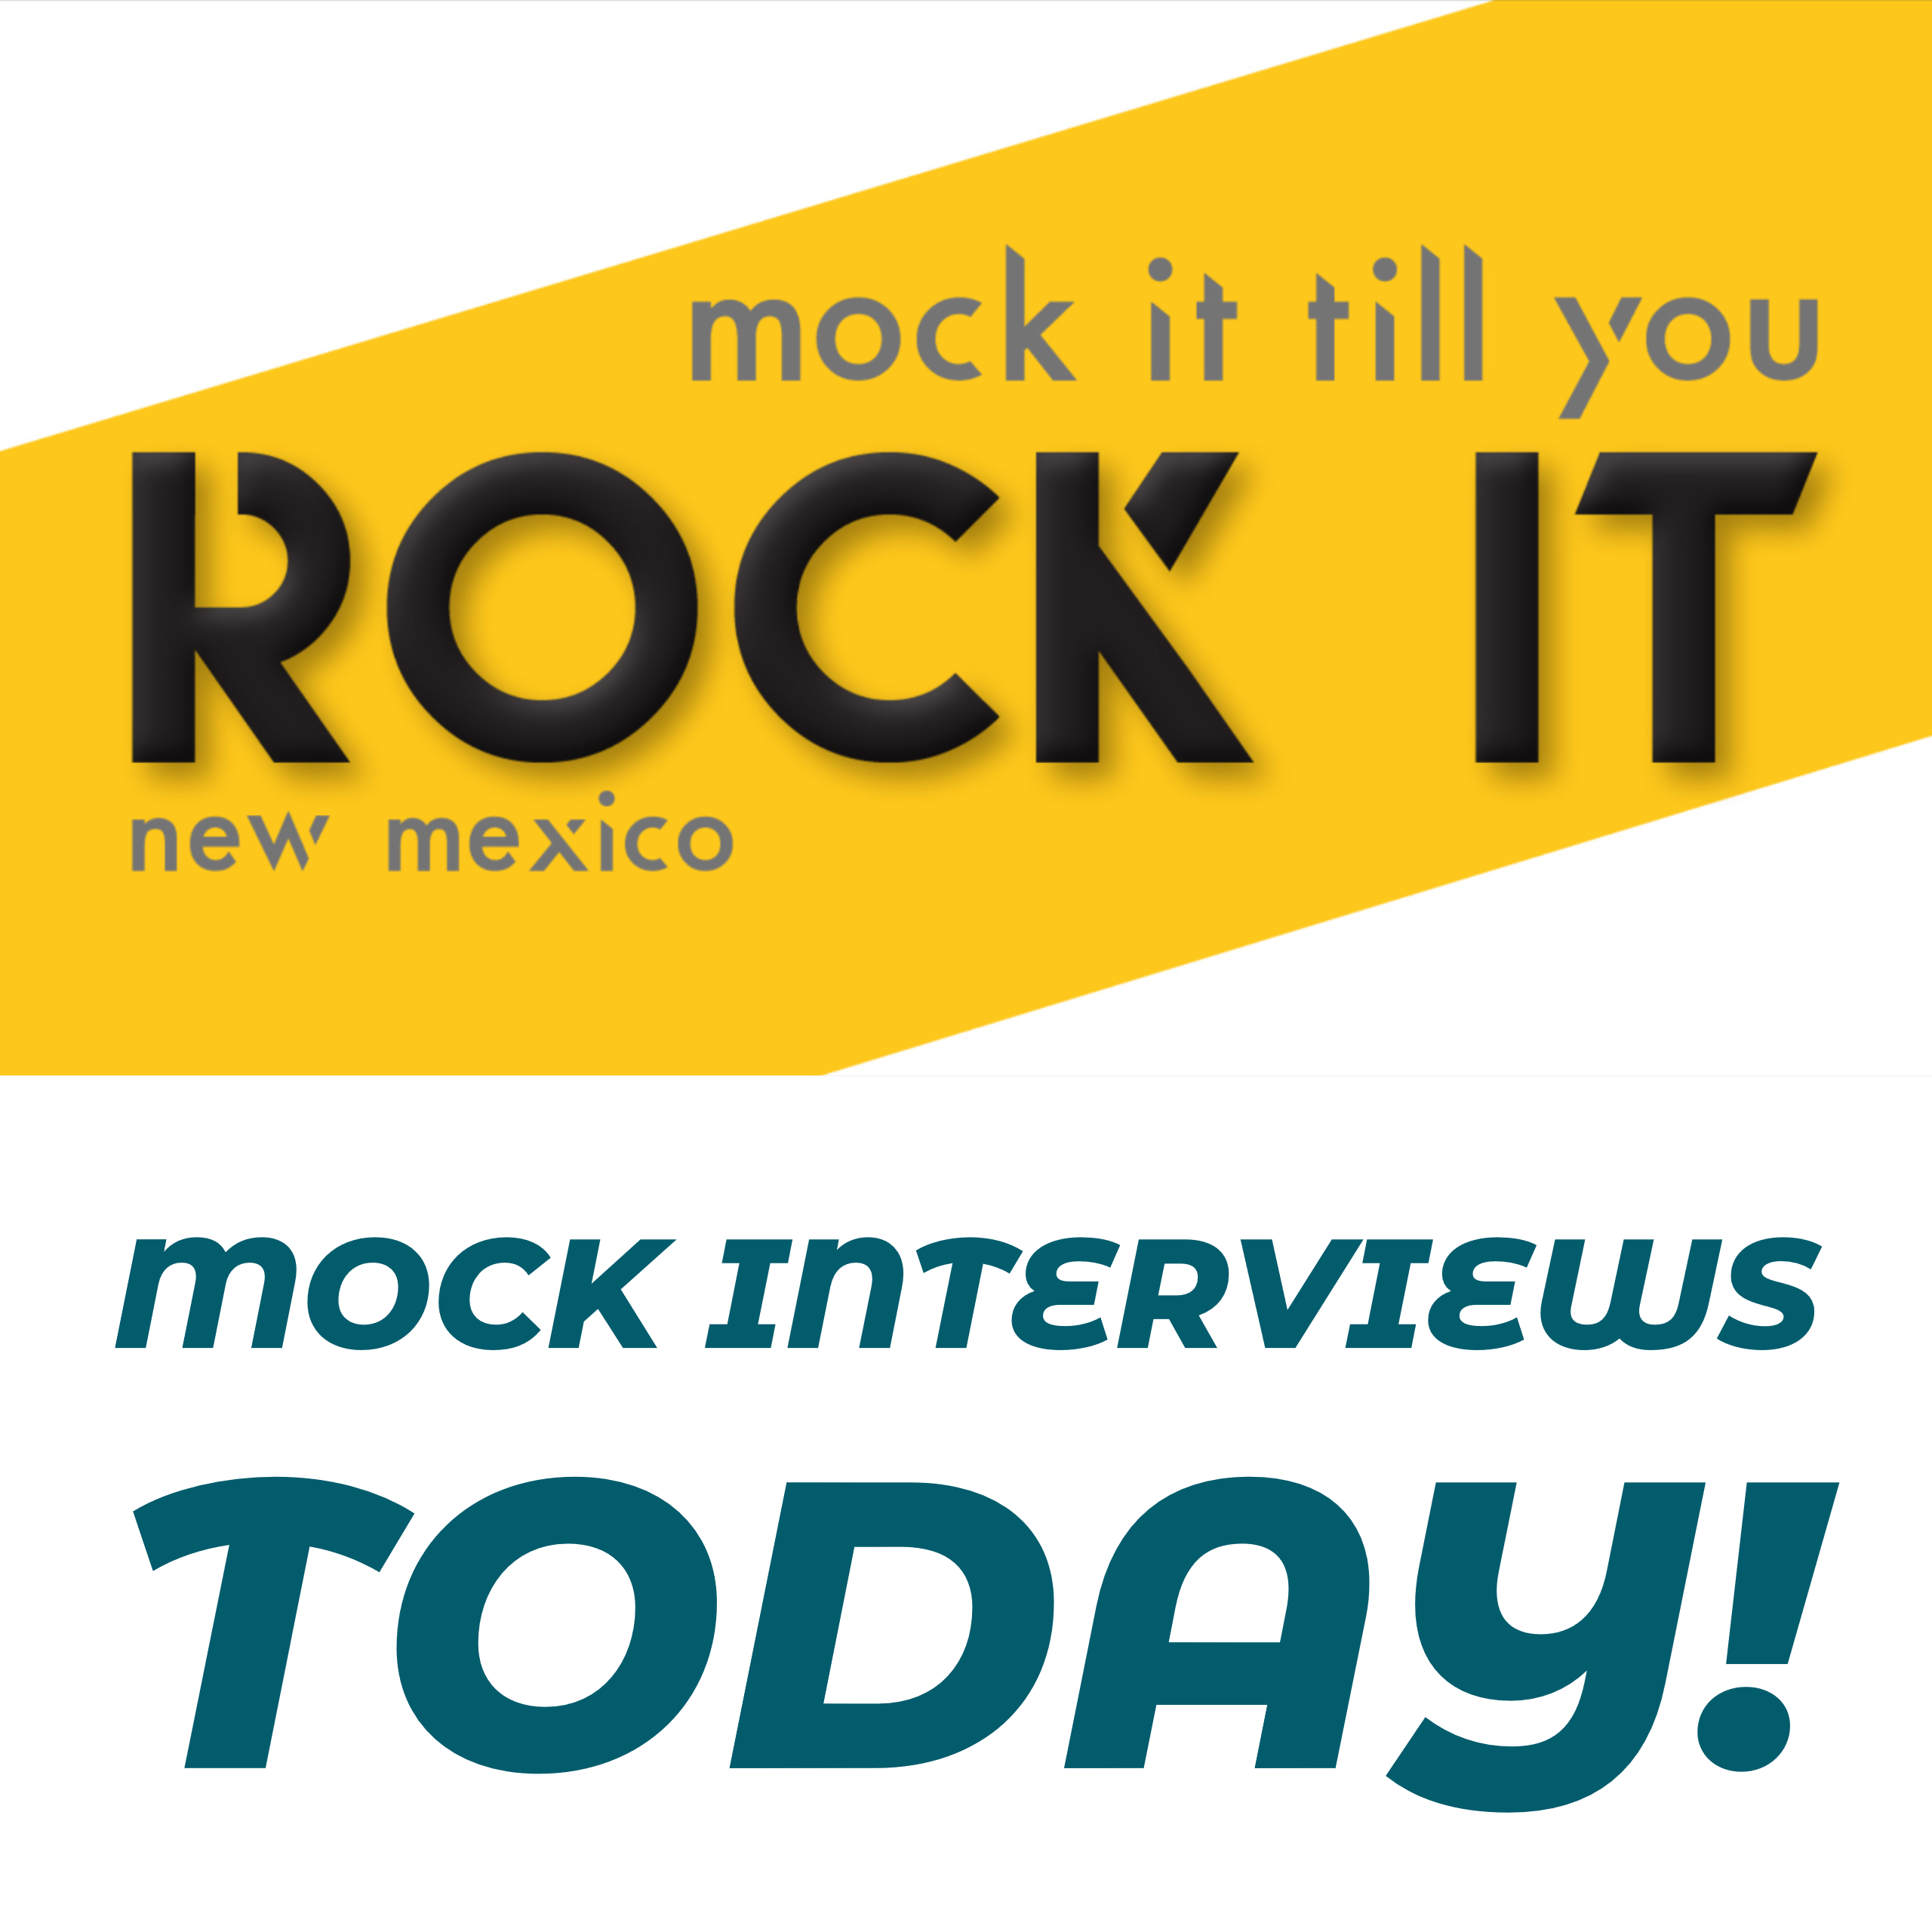
Post 2:
Mock Interviews TODAY at {school/organization}! @NMDWS #MockItTillYouRockItNM #mockinterviews #students #softskills #careerreadiness

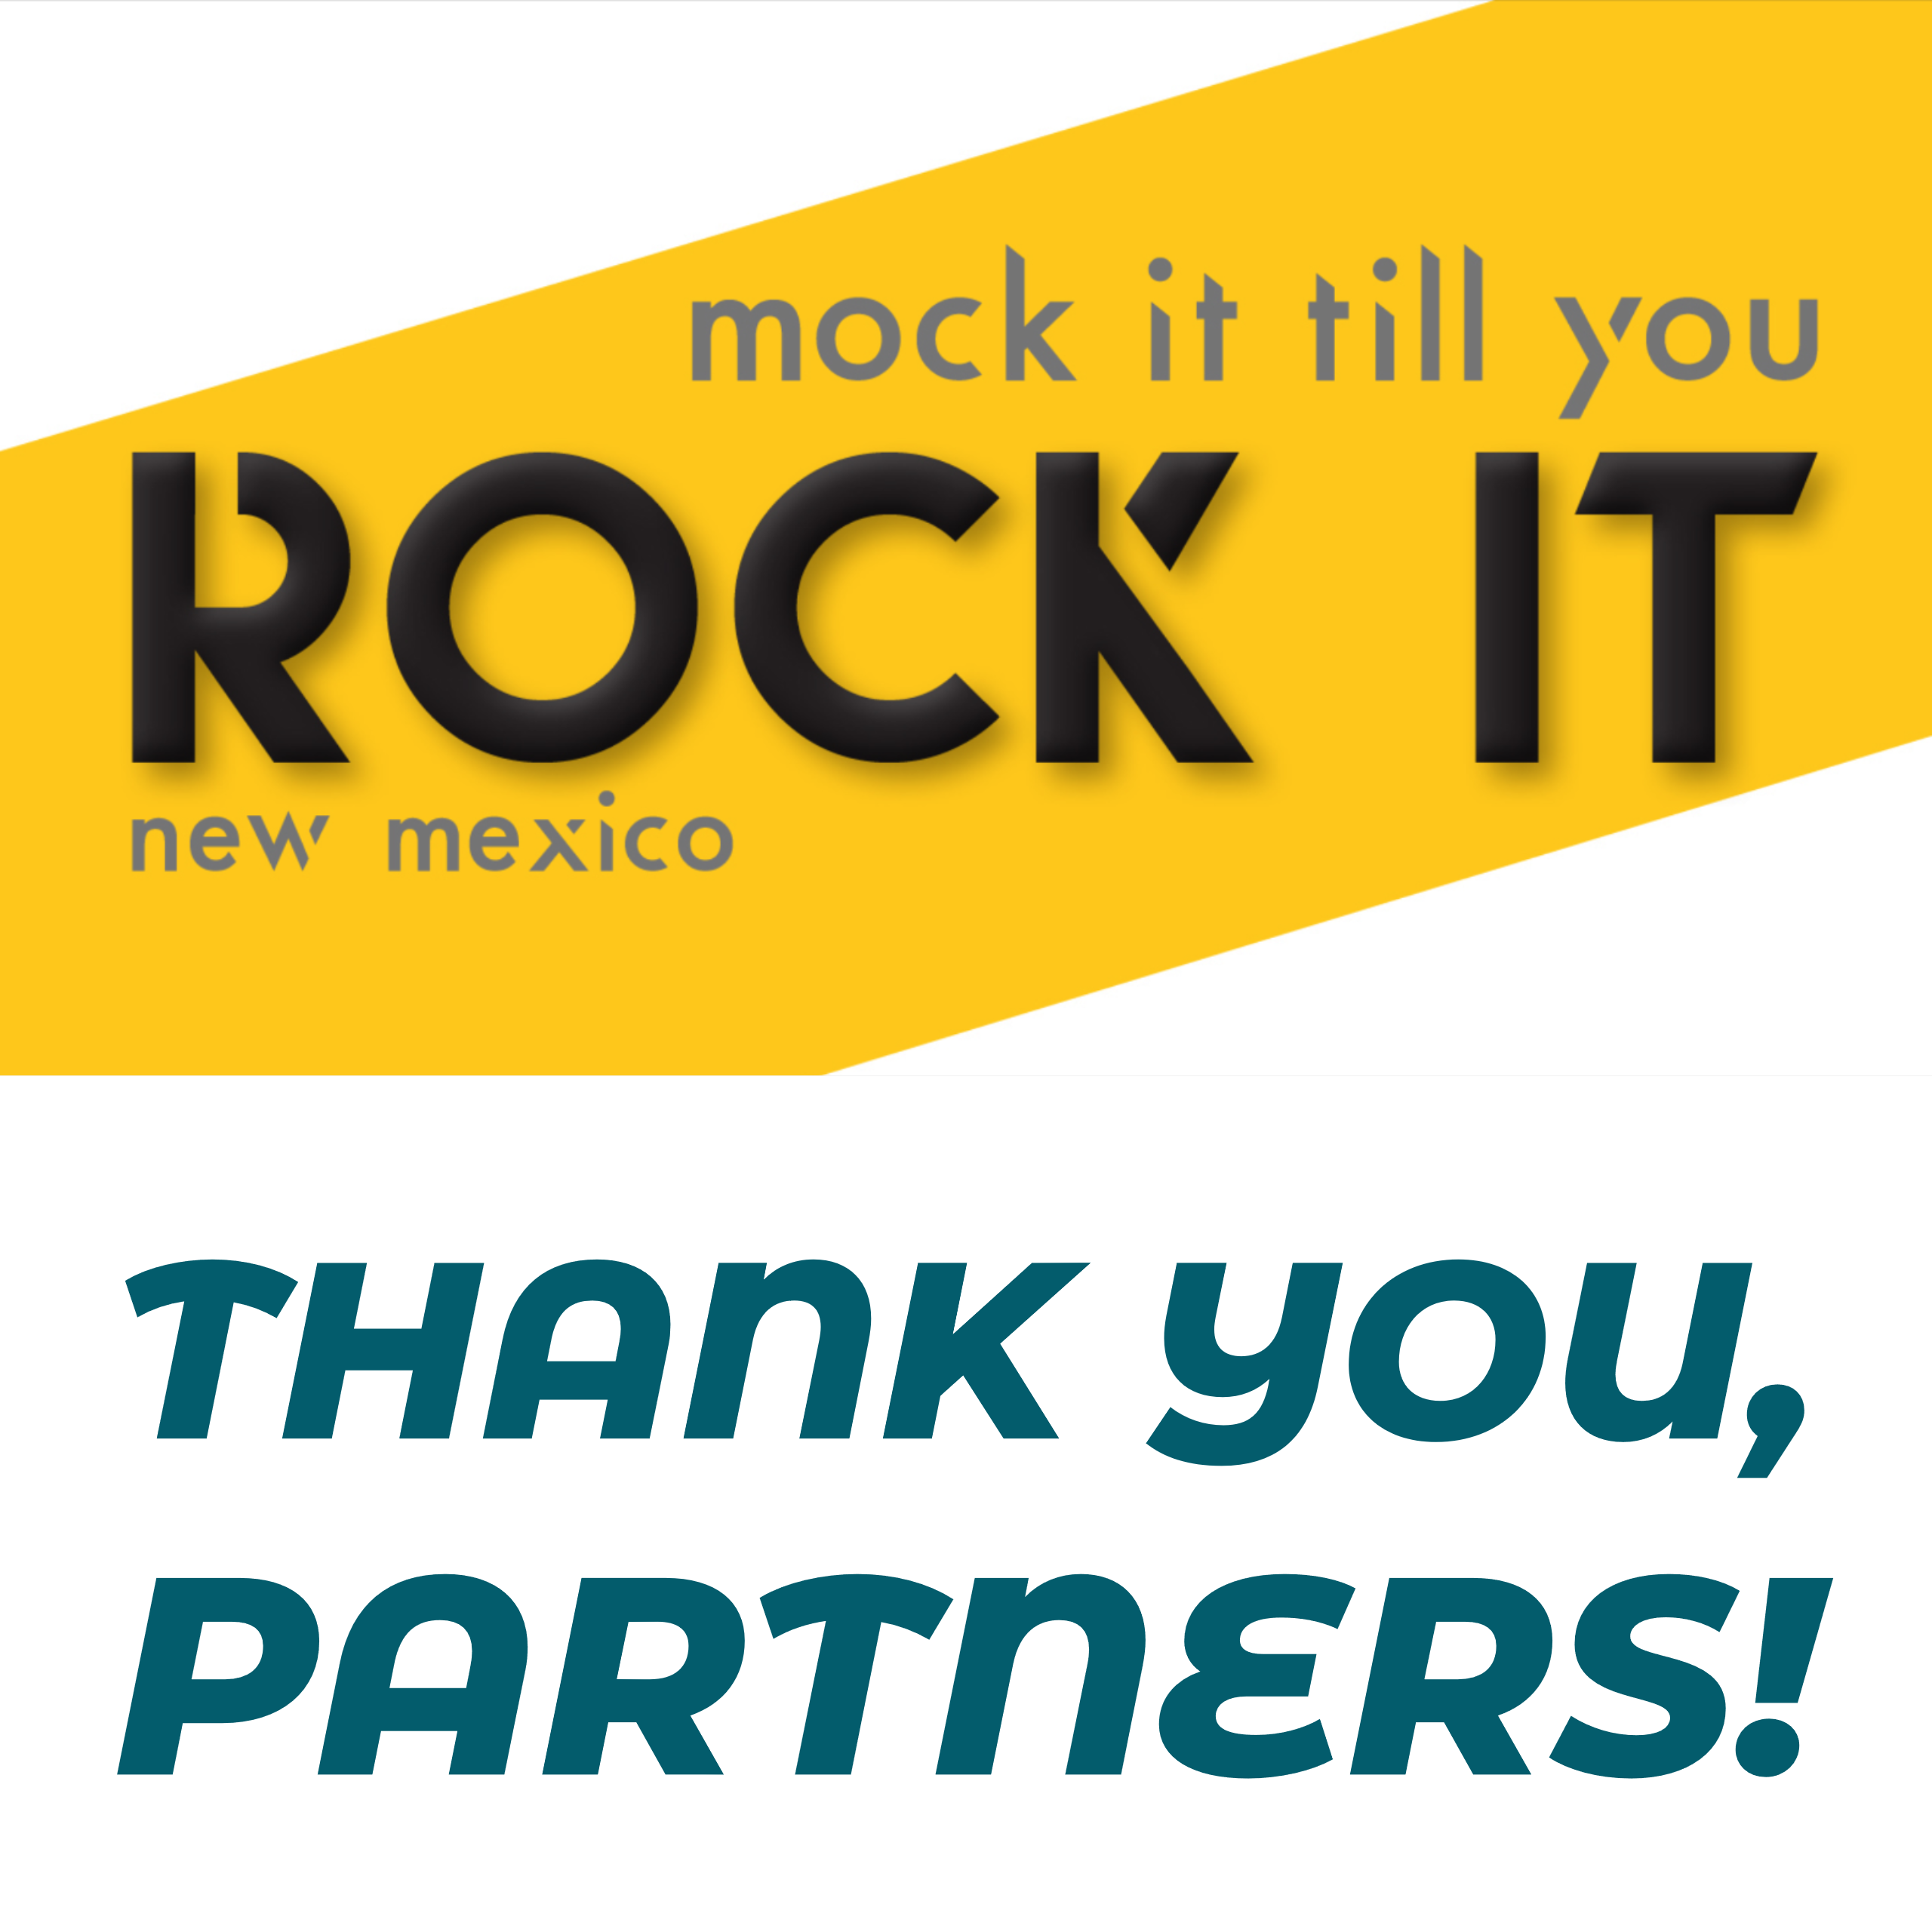
Post 3:
A big thank you to all of our community partners who volunteered to help make our Mock Interview Event a success! @NMDWS #MockItTillYouRockItNM #mockinterviews #students #softskills #careerreadiness

